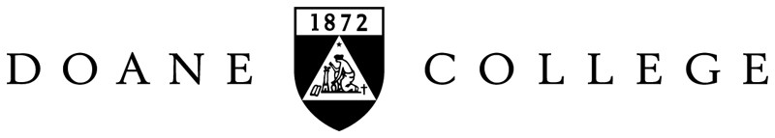

Library Donation Form

Thank you for your donation of books or materials to Perkins Library at Doane College. The library appreciates your support. Please consult the Doane College Library Materials Gift Policy (on the reverse side of this form) before donating your material. No gift will be accepted without a signed Donation Form.
Donor Information

Date: .
Name: .
Address: .
Phone: .
Email: .

Approximate number of items: .
General description of materials (e.g. books, journals, DVDs): .

□ I wish to pick up any materials not added to the Library’s collection.

Please check one:
I will not take a tax deduction for this donation and do not need a receipt from the College.
I will take a tax deduction for this donation and would like a receipt from the College. (Donor must supply the value of all items.)

Your signature on this form acknowledges that the gift material is now the property of Doane College, and anything not added to the collection may be sold, offered to other libraries, or otherwise disposed of at the Library’s discretion unless other arrangements have been made with the Collection Development Librarian. In accordance with Internal Revenue Service code, the Doane College Library can not appraise gifts. It is the donor’s responsibility for determining value.

I have read the Doane College Library Materials Gift Policy and agree that my donation will be handled according to its stated terms.

Signature: .

This form is to accompany all donated materials upon delivery to the Library.

FOR OFFICE USE

Name of person accepting donated items: Date: .
Doane College Library Gift Materials Policy:

A. The College Library is frequently offered books and other materials as gifts. Although many excellent and important items have been added to the collection in this matter, some of what is offered is of no value to the library. Because this can often involve public relations, space and relevancy problems, a clearly stated policy on the matter of gifts and donors is necessary.
  - No definite commitment to accept gifts for the library shall be made by anyone except the President of the College or the Director of the Library.

  - All such offers made directly or indirectly to others should be referred to the library director.

  - The Director of the Library shall have the prerogative of refusing to accept materials which s/he believes do not contribute to the purpose of the Library or that cannot be accommodated suitably at the time. However, the materials may be accepted if the donor is willing to allow them to be added to the ongoing book sale, which in a direct way benefits the library with the funds generated; or if the donor will allow unneeded journals to be added to the annual Duplicate Exchange lists to benefit some other college.

- With regard to gifts accepted, several points shall be made clear to the donors.

  - The library director shall determine the classification, housing, and circulation practices of all gift items, just as with purchased materials.

  - The Director of the Library retains the right to dispose of all duplicates and unneeded materials as is determined to be appropriate, whether through Duplicate Exchange, by donation to more appropriate archives and special collections at Doane or elsewhere, by sale to benefit Perkins Library, or by other means.

  - All donations are tax deductible. Doane College, however, can assume no responsibility for determination of the value of the gift beyond suggesting appraisers to the donor.

  - All donations are considered outright and unconditional gifts to be used at the library’s discretion.

Guidelines for Donating Material:
If you are considering donating to the Library, we urge you first to contact the Collection Development Librarian to discuss the usefulness of a proposed gift. You will be asked to fill out a Library Donation Form before your gift will be accepted. If a list of donated items is desired, the list must be completed by the donor in advance of delivery. After the gift enters the Library we are not able to accommodate a review of the donation, since processing distributes the items. The Library will acknowledge all gifts and forward the details to the Advancement Office, who will send a receipt to the donor for tax purposes if one is requested.

The most useful donations for this Library are new books and replacements for missing items that enrich current college instruction. Academic libraries have specific needs that frequently exclude donated items such as: standard editions of classic works, which usually duplicate current holdings; textbooks, which become outdated; books printed on paper too brittle to make them usable; materials in formats not collected by the Library (e.g., books on tape or CD-ROM); back-runs of periodicals that do not fill gaps in the library’s holdings; or short runs of periodical titles. Note: We are accepting fewer print periodical donations due to the acquisition of online periodical resources and space limitations.

